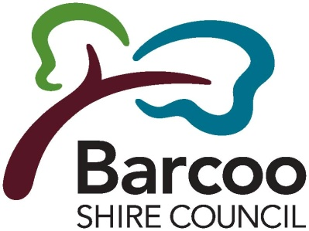
Barcoo Shire Council
ABN 34668298330 6 Perkins Street Po Box 14
Jundah Qld 4736
T: 07 46586900
F: 07 46586137
E: shire@barcoo.qld.gov.au
W: www.barcoo.qld.gov.au

WATER COMPLAINT FORM

This form is to be completed when making a complaint about the Water Supply in accordance with the Barcoo Shire Council Customer Service Standards – Water Supply.

CUSTOMER DETAILS
Customer Name:
Customer Address:
Contact Number:
Date: | / / |  |  |  | Time: |  | AM / PM
COMPLAINT DETAILS: (Please tick box)
□ Treated Water Supply |  |  |  | □ Planned Interruption |  | □ Billing / Accounts
□ Raw Water Supply |  |  |  | □ Unplanned Interruption |  | □ Other :
COMPLAINT TYPE: (Please tick box) |  |  |  | Additional Comments / Diagrams (Optional)
□ Water Quality
□ Pressure
□ Disruption
□ Leak
□ Main break
□ Other (Please Specify):
LOCATION OF ISSUE / FAULT: (Please detail street address)
ACTIONS YOU WOULD LIKE AS A RESULT OF THIS COMPLAINT:
CUSTOMER’S SIGNATURE:
OFFICE USE ONLY:
Received in Office by: |  |  | Date: / / Time: AM/ PM
Responsible Officer:
Response / Action Details:
Response Time
(Breaks & Leaks)
Action Completed by: |  |  | Date: / / Time: AM/PM
Authorisation Signature: |  |  | Date: / / Time: AM/PM
This complaint and action/s have been recorded on the Water Complaints Register: □ YES □NO |  |  |  |  |  |  |  | DOCUMENT ID NO:

